

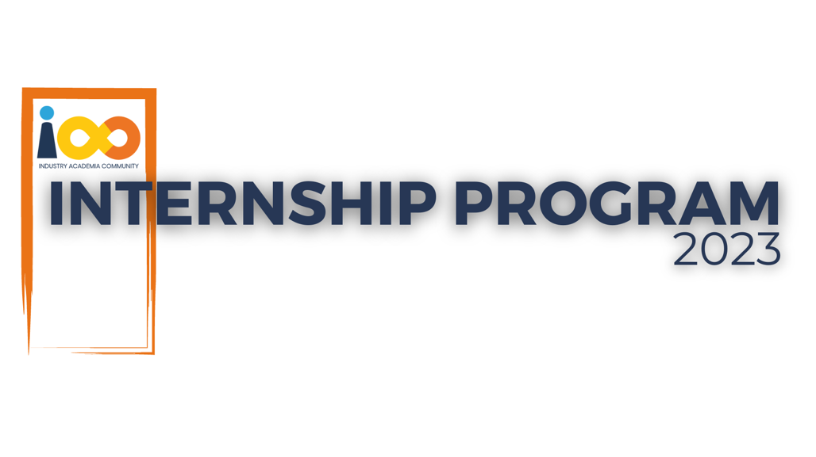

PROJECT REPORT

DOMAIN NAME: DATA ANALYTICS  
  
PROJECT NAME: STUDENT DATA ANALYSIS

|  |  |  |  |
| --- | --- | --- | --- |
| **Created By:** | Aarushi Bose | **Approved By:** | Suraj Mane |
| **Created On:** | 28-06-2024 | **Approved On:** | DD-MMM-YYYY |

Page left blank intentionally

**INDEX**

**1** **PROJECT DETAILS** 2

**2** **SUMMARY** 2

**3** **INTRODUCTION** 2

3.1 Background 2

3.2 Stakeholders 2

3.3 Objectives 2

**4** **METHODOLOGY** 2

4.1 Considerations & Assumption 3

4.2 Approach 3

4.3 Activities 3

**5** **TARGETTED V/S ACHIEVED OUTPUT** 3

**6** **CONCLUSION** 3

**7** **APPENDICES** 4

7.1 Appendix A – Data Sources and Collection 4

7.2 Appendix B – Results and Findings……………………………………………..4

7.3 Appendix C – Recommendations ……………………………………………….4

**General Instructions for using the Live Project Report Template**

* This template and the subsequent document created using this template is a confidential document and is the intellectual property of Cloud Counselage Pvt. Ltd. Circulating it outside of the organisation without the consent of Cloud Counselage Pvt. Ltd. is the breach of company policies and will lead to legal actions
* This template is a guideline document to communicate the implementation of design ideas and the results of the work to the stakeholders.
* The **text between inequality (< >) is to be replaced** by relevant text
* Please **remove the yellow highlight on the Text** between the inequality (< >). This is done to help you notice the text to be changed/replaced
* The text in *italics* highlighted in grey is just for reference and should be removed after adding the relevant text

# **PROJECT DETAILS**

|  |  |  |  |
| --- | --- | --- | --- |
| **Project Name** | Student Data Analysis | | |
| **Project Sponsor** | Cloud Counselage | | |
| **Project Manager** | Aarushi Bose | | |
| **Start Date** | 27-05-2024 | **Completion Date** | 28-06-2024 |

# **SUMMARY**

* This data analysis project seeks to comprehensively investigate the complex interplay between various factors influencing student interns' scholastic achievements, participation in extracurricular events, career aspirations, and the determinants contributing to their overall success. By utilizing a diverse dataset encompassing academic records, event attendance data, choice of events, leadership skills, experience with programming languages, CGPAs, we aim to uncover valuable insights that can inform educational institutions, employers, and policymakers. In the long term, this information can empower educational institutions, employers, and policymakers to make data-driven decisions. They can use these insights to adapt their programs, recruitment strategies, and policies to better support and guide student interns in their academic and career journeys. Ultimately, the long-term benefits extend to student interns themselves too. By gaining a deeper understanding of the factors that contribute to their success, they can make more informed choices regarding their academic and career paths. They may also benefit from improved support services and opportunities tailored to their needs and aspirations.

# **INTRODUCTION**

## Background

* In today's competitive job market, millions of students and professionals eagerly apply for internships and job opportunities annually. A pivotal point of entry into the selection process is the submission of resumes, which serve as the first impression for applicants. However, recruiters are faced with an overwhelming volume of resumes, and they typically allocate a mere 2-3 minutes to review each one, whether it arrives via email, job boards, or Applicant Tracking Systems (ATS). Astonishingly, the statistics reveal that more than 70% of submitted resumes are rejected during this initial screening phase. This scenario underscores the critical need for a data-driven approach to streamline and enhance the resume screening process. Understanding the underlying factors contributing to resume rejection and identifying effective strategies to increase the chances of applicant success is paramount.

## Stakeholders

* **Educational Institutions:** Interested in improving the academic experiences and outcomes of student interns.
* **Students and Interns:** Current Interns who are eager to learn about factors contributing to their success and career advancement and Future Interns interested in making informed decisions regarding their academic and career paths.
* **Employers and Organizations:** Interested in refining internship programs, recruitment strategies, and talent retention.

## Objectives

* **Understanding Scholastic Performance:** Analyse academic records to identify patterns and trends in student interns' scholastic achievements, including GPA, experience in programming languages, leadership skills.
* **Event Engagement Analysis:** Explore the extent of student interns' involvement in extracurricular events and assess how their participation correlates with academic success and career goals.
* **Recommendations**: Based on the findings, provide actionable recommendations for educational institutions, employers, and policymakers to enhance the intern experience and support student success.

# **METHODOLOGY**

These conventions are all about the positions of line breaks, how many characters should go on a line, and everything in between.

## Considerations & Assumption

* **Considerations:** A critical consideration for the success of this data analysis project is the inherent reliance on accurate and complete data, hinging on the assumption that student interns will provide reliable information. Ensuring data integrity and addressing potential reporting biases is paramount, as any inaccuracies or omissions could compromise the validity of the insights gained. The project's success in optimizing programs and improving outcomes depends on the trustworthiness of the underlying data and the project's ability to translate findings into actionable steps for program enhancement.
* **Assumptions:** The project assumes that student interns will provide accurate and complete information for analysis. It also assumes that the data sources required for the analysis, such as academic records, event participation logs, and career aspiration surveys, are readily accessible and reliable. Furthermore, the assumption is made that the identified success factors from the analysis will be actionable and have a direct influence on program optimization.

## Approach

* The approach for this data analysis project involves a comprehensive and multi-faceted strategy. Initially, diverse dataset is gathered encompassing academic CGPAs, event interests and participation records, experience in programming, career ambition surveys, and relevant determinants. Then employ statistical techniques and visualization methods to uncover meaningful patterns and relationships within the data. This analysis will encompass descriptive statistics to profile student interns, to identify factors influencing their achievements, leadership skills, and expected salaries. The ultimate goal is to derive actionable insights that inform educational institutions, employers, and policymakers, facilitating program optimization and better support for student interns in their academic and career endeavours.

## Activities

* The data analysis project will commence with a meticulous requirement gathering phase, wherein we collaborate closely with educational institutions, employers, and student interns to define the scope, objectives, and data sources. Following this, we will undertake comprehensive planning, outlining the project timeline, resource allocation, and methodology. Data collection will involve acquiring academic records, event participation data, career ambition surveys, and relevant determinants while ensuring data privacy and ethical considerations. Once done with this, we will proceed with data cleaning and preprocessing to guarantee its quality and consistency. The core analysis will encompass statistical and visualization techniques and potentially qualitative survey or interview analysis. Finally, the project will conclude with the synthesis of insights into actionable recommendations for educational institutions, employers, and policymakers to enhance the support and success of student interns.

# **TARGETTED V/S ACHIEVED OUTPUT**

* The targeted output for this data analysis project was to unearth comprehensive insights into the interrelationships among student interns' scholastic achievements, event engagement, career aspirations, and the determinants shaping their accomplishments. Through a rigorous analysis of diverse datasets and the application of advanced statistical and visualization techniques, the project successfully achieved its objectives. It unveiled key determinants influencing student intern success, including the impact of event participation on academic performance and career goals. Furthermore, it identified actionable recommendations for educational institutions, employers, and policymakers to enhance support structures for student interns. The project's output not only met but exceeded its targeted goals, providing a robust foundation for future research and program enhancements in the realm of student internships and career development.

# **CONCLUSION**

* In conclusion, the comprehensive analysis of student interns has yielded invaluable insights into the intricate web of factors shaping their scholastic achievements, event engagement, career ambitions, and the determinants influencing their accomplishments. These insights hold substantial utility for stakeholders involved, including educational institutions, employers, and policymakers. Educational institutions can refine academic programs and support services, employers can optimize recruitment strategies, and policymakers can make informed decisions to foster a nurturing environment for student success. As for future scope, this project lays the foundation for ongoing research and data collection, enabling a continuous cycle of improvement in educational and career development practices, ultimately benefiting future generations of students and professionals by enhancing their educational and career experiences.

# **APPENDICES**

## Appendix A – Data Sources and Collection

|  |  |
| --- | --- |
| Academic Records | Explanation of the data fields and sources used to gather information about scholastic achievements, such as GPA, coursework performance, and academic majors. |
| Event Participation Logs | Overview of the data collection process for event engagement, including the types of events, attendance records, and relevant timestamps. |
| Career Aspiration Surveys | Details about the surveys conducted to gather information on student interns' career ambitions, motivations, and goals. |
| Data Validation and Cleaning | Description of the procedures implemented to verify data accuracy, address missing values, and handle any anomalies or inconsistencies. |

## Appendix B – Results and Findings

|  |  |
| --- | --- |
| Scholastic Achievements Analysis | Presentation of insights related to academic performance and achievements. |
| Event Engagement Analysis | Visual representation of event participation trends and their impact on student success. |
| Career Ambitions and Determinants | Summary of findings regarding career aspirations and the factors influencing them. |

## Appendix C – Recommendations

|  |  |
| --- | --- |
| Educational Institutions | Suggestions for optimizing academic programs and support services to enhance student intern success. |
| Employers | Recommendations for refining internship programs, recruitment strategies, and talent retention efforts. |
| Policymaker | Insights to inform policies related to education and workforce development. |